EXPERIMENT 4 .
- AIM:
To design and implement OLAP operations using Microsoft Power BI on the Global Superstore dataset, enabling interactive analysis of business data through Slicing, Dicing, Drill Down, and Drill Up operations for effective reporting and decision-making.

- OBJECTIVES:
- To understand the concept of OLAP and its role in Business Intelligence.
- To understand different OLAP operations such as Slicing, Dicing, Drill Down, and Drill Up.
- To implement Slicing operations using Power BI slicers and filters.
- To implement Dicing operations by applying multiple filters across different dimensions.
- To implement Drill Down operations using hierarchical data.
- To implement Drill Up operations to summarize data from detailed to higher levels.
- To create interactive visualizations for multidimensional business analysis.
- To analyze Sales, Profit, Orders, Category, Segment, Region, and Year using OLAP operations.
- TOOLS / SOFTWARE REQUIRED:
- Microsoft Power BI Desktop
- Global Superstore Dataset.xlsx
- Power Query Editor – built into Power BI Desktop
- DAX (Data Analysis Expressions)

- DATASET USED: Global Superstore Dataset.xlsx.

- THEORY:
- OLAP (Online Analytical Processing) is a technology used in Business Intelligence to perform multidimensional analysis of business data and support analytical decision-making.
- OLAP Operations allow users to examine data at different levels of detail and from different perspectives.
- Slicing is an OLAP operation that selects a single value or subset from one dimension to create a smaller view of the multidimensional dataset. In Power BI, slicing can be implemented using slicers and filters such as Region, Category, or Year.
- Dicing is an OLAP operation that selects a subset of data by applying filters across multiple dimensions simultaneously. For example, data can be analyzed for selected Regions, Categories, and Years.
- Drill Down is an OLAP operation that moves from a higher-level summary to a more detailed level of data. For example, geographical data can be analyzed from Region to Country, City, and State.
- Drill Up is the reverse of Drill Down. It moves from detailed data to a higher-level summary, allowing users to aggregate information from lower levels to higher levels.
- Power BI provides interactive visualizations, slicers, filters, and hierarchies that allow users to perform OLAP operations dynamically.
- OLAP operations help users identify trends, compare business performance, analyze geographical information, and examine sales and profit at different levels of detail.
- PROCEDURE:
Part A: Load Dataset
Step 1: Open Microsoft Power BI Desktop.
Launch Microsoft Power BI Desktop.
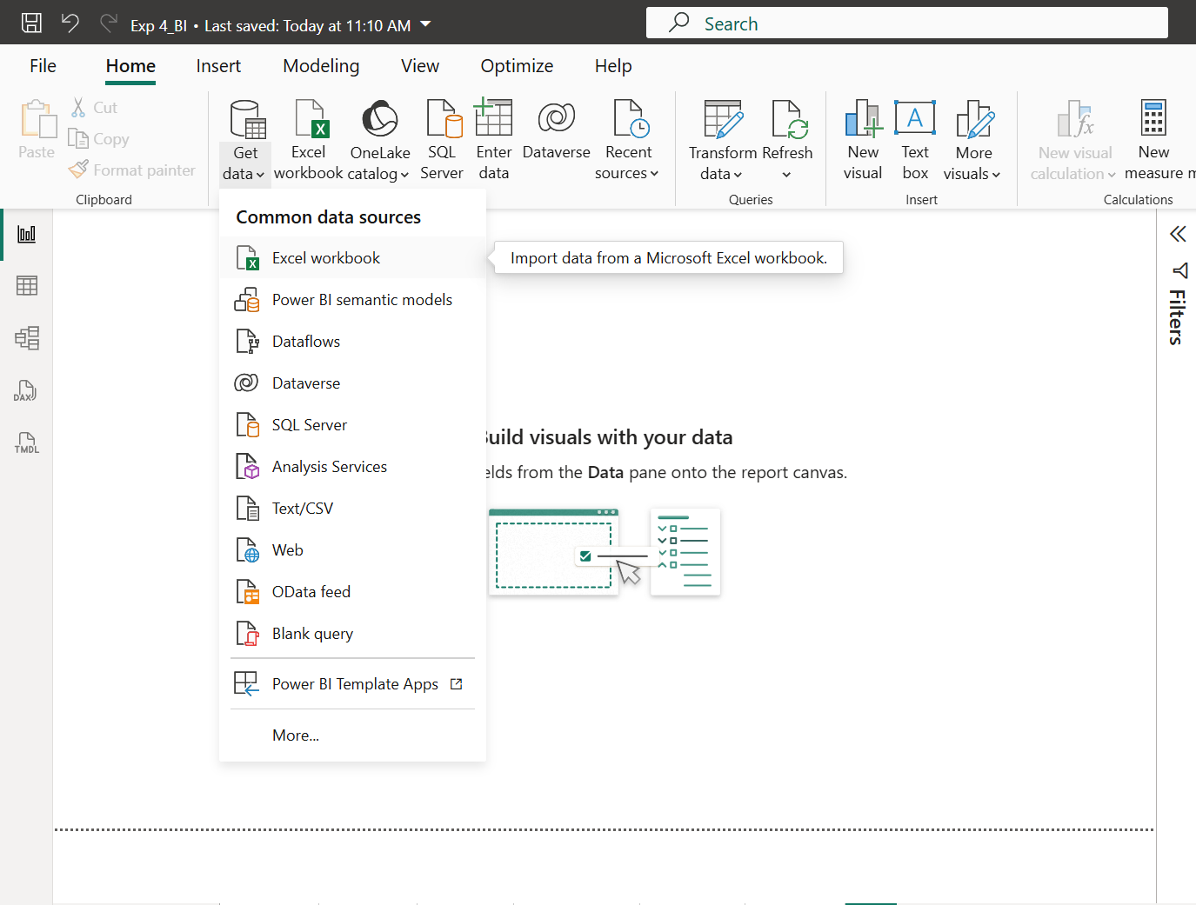
Fig 4.1: Microsoft Power BI Desktop
Step 2: Connect to the Global Superstore dataset.
Go to: Home > Get Data > Excel Workbook
Select: Global Superstore Dataset.xlsx
Load the required data into Power BI.
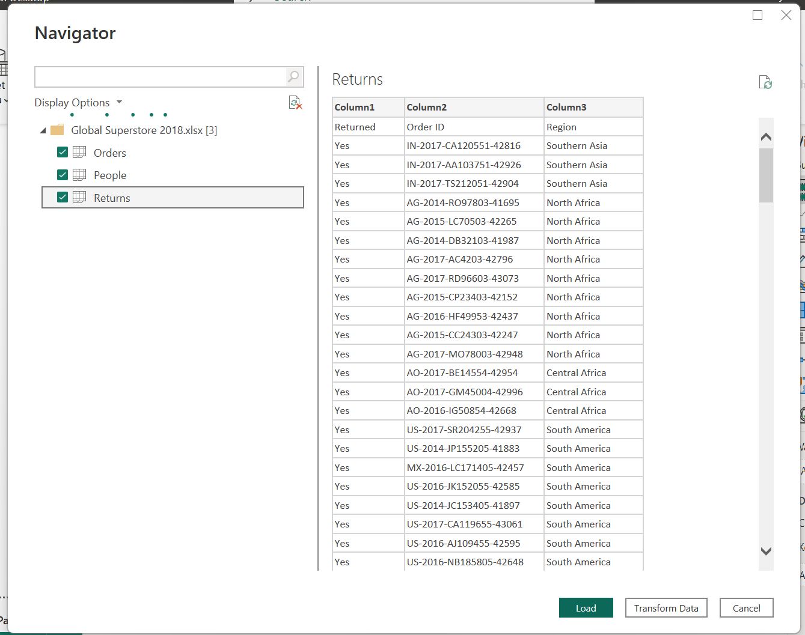
Fig 4.2: Connecting Power BI to the Global Superstore dataset
Step 3: Verify the dataset.
Verify that the required tables and fields such as: Sales, Profit, Order ID, Category, . Segment, Region, Country, City, State, Year; are available for analysis.
Part B: Create Analytical Measures
Step 4: Create Total Sales measure.
Select the appropriate data table and create a new measure:
Total Sales = SUM (Orders [Sales])
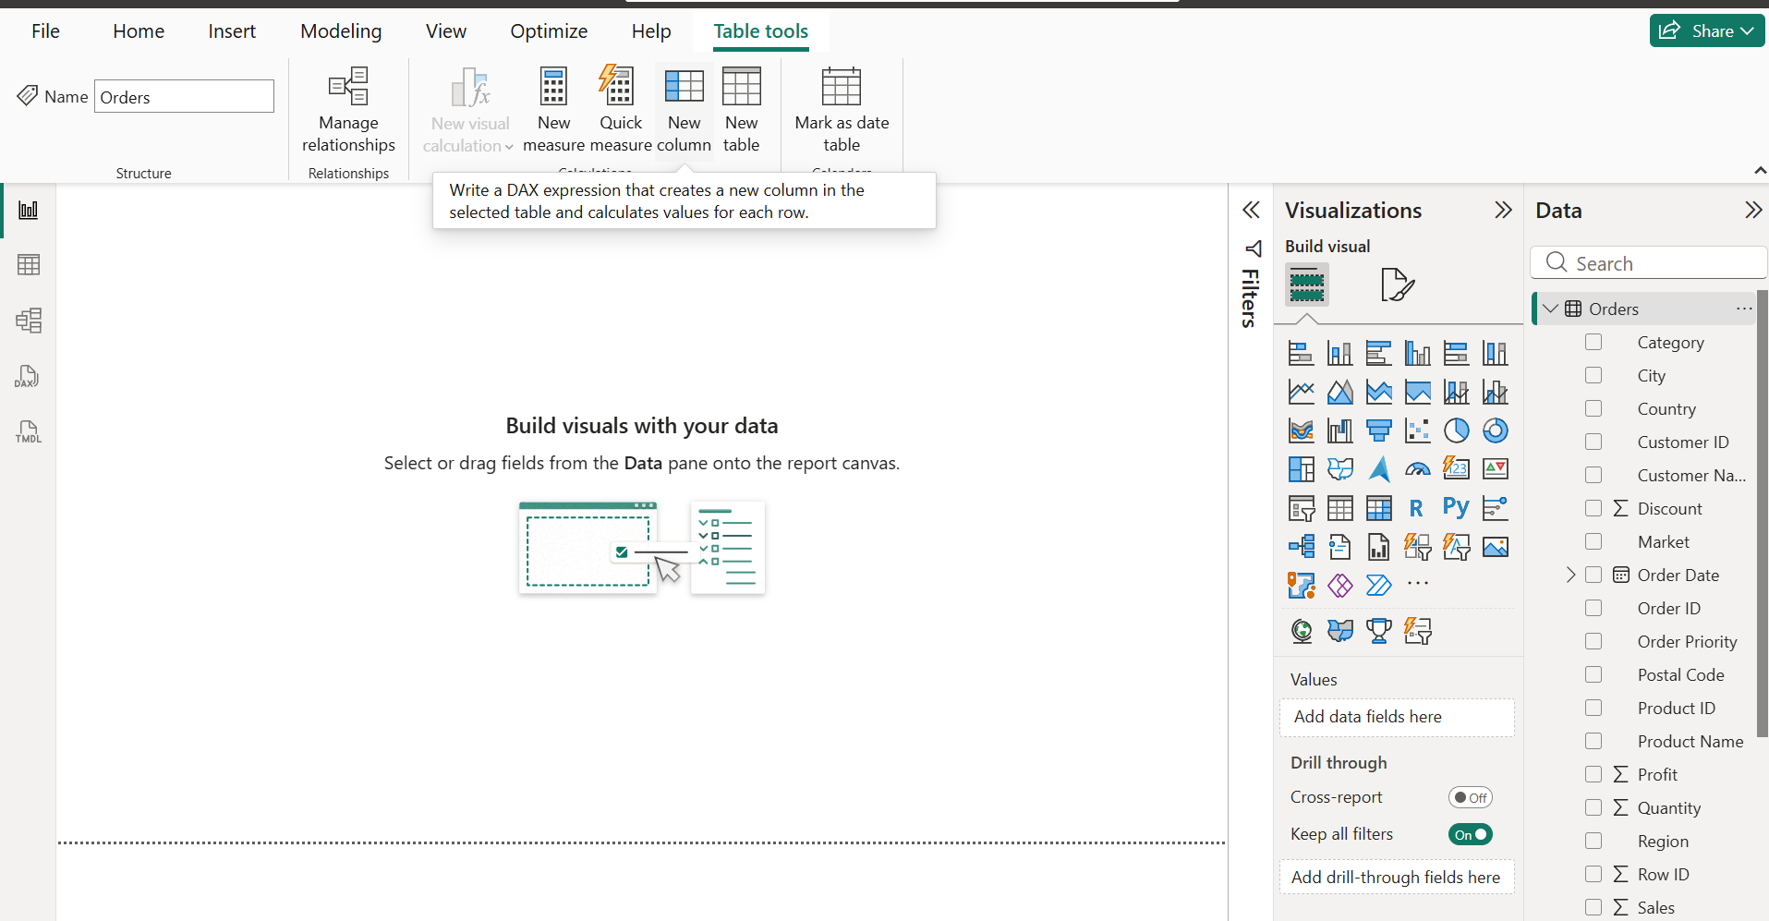 | 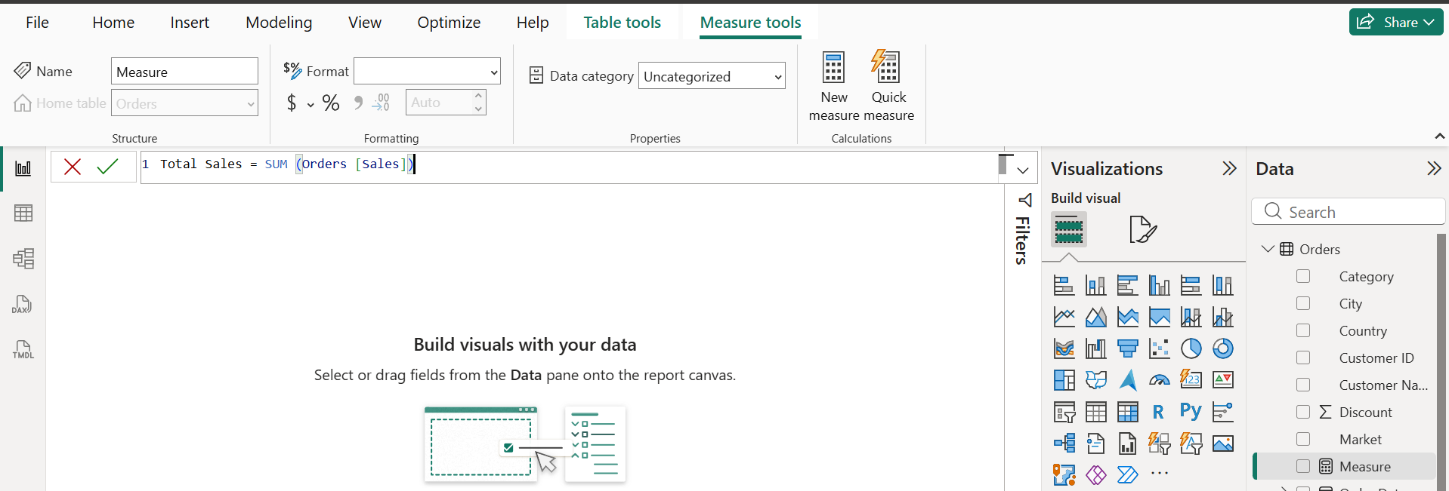
Fig 4.3: Creation of Total Sales measure using DAX

Step 5: Create Total Profit measure.
Create: Total Profit = SUM (Orders [Profit])
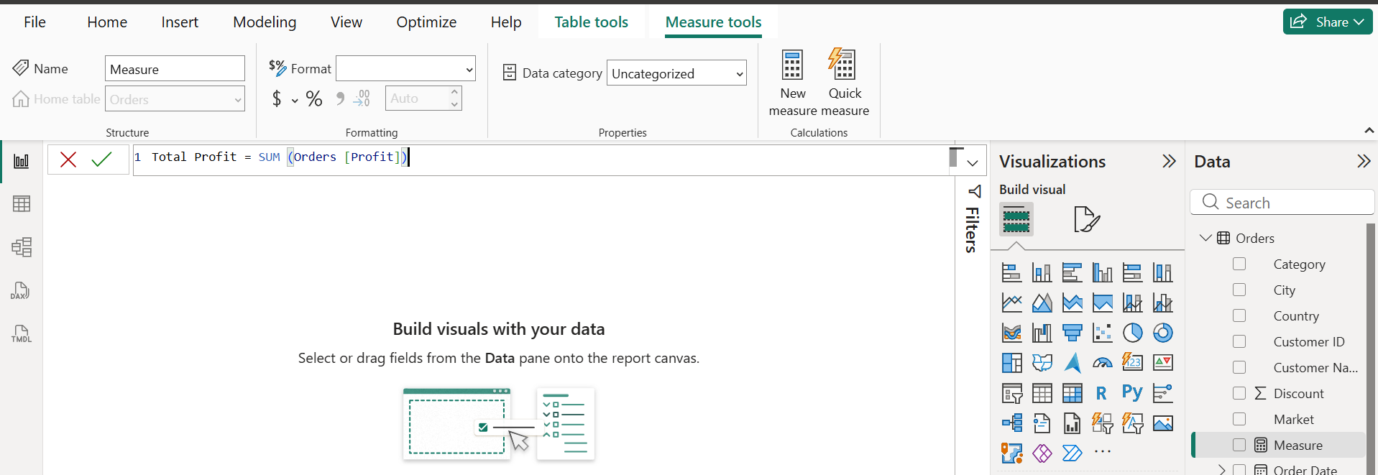
Fig 4.4: Creation of Total Profit measure using DAX

Step 6: Create Total Orders measure.
Create: Total Orders = DISTINCTCOUNT (Orders [Order ID])
These measures are used throughout the OLAP dashboards for analytical comparison.
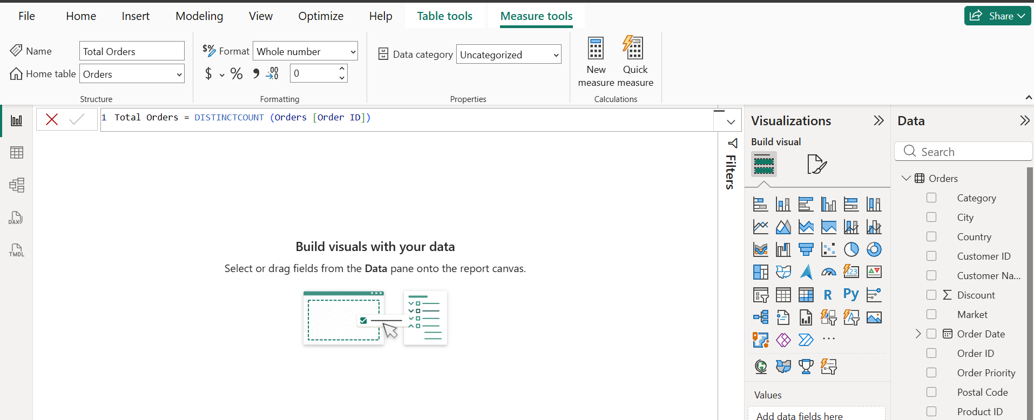
Fig 4.5: Creation of Total Orders measure using DAX

Part C: Implement OLAP Slicing
Step 7: Create the Slicing worksheet.
Create a new Power BI report page and rename it:
OLAP Operation – Slicing
Step 8: Add a Region slicer.
Insert a Slicer visual and add:
Region
The slicer allows a particular Region to be selected for analysis.
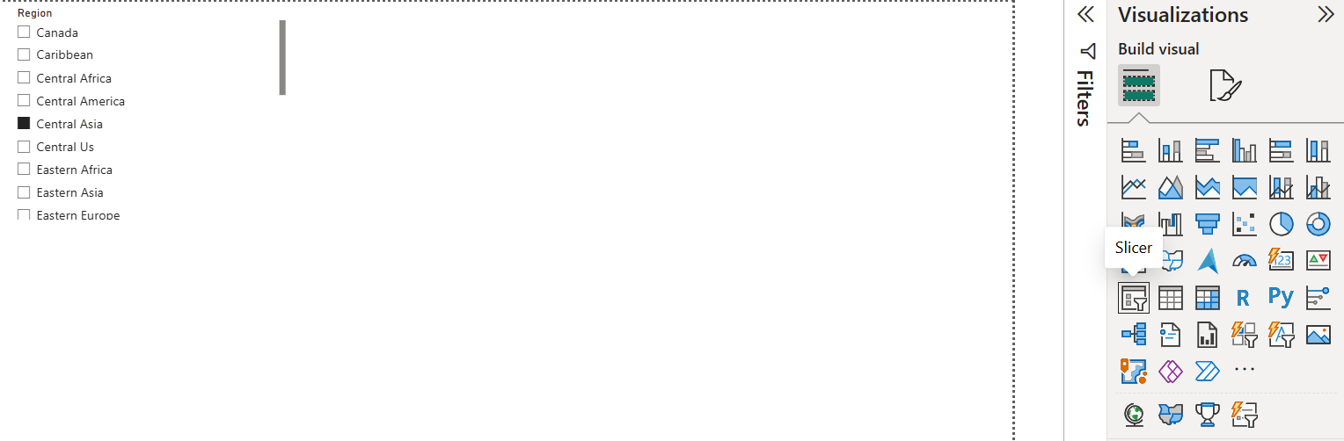
Fig 4.6: Region slicer for OLAP Slicing

Step 9: Create Slicing visualizations.
Create visualizations for: Total Sales, Total Profit, Total Orders, Sales by Category, Profit . by Category, Sales Trend by Year, Sales by Segment.
When a Region is selected from the slicer, the visualizations are filtered to display the . . selected slice of the dataset.
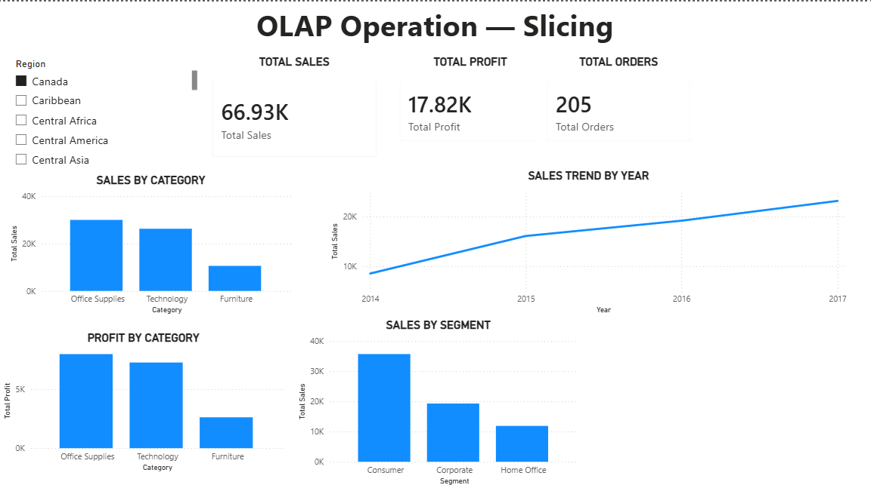
Fig 4.7: OLAP Operation – Slicing dashboard

Part D: Implement OLAP Dicing
Step 10: Create the Dicing worksheet.
Create a new Power BI report page and rename it:
OLAP Operation – Dicing
Step 11: Apply multiple dimensional filters.
Create slicers/filters for:
• Region
• Category
• Year
These filters allow a specific subset of the dataset to be selected using multiple . . dimensions.
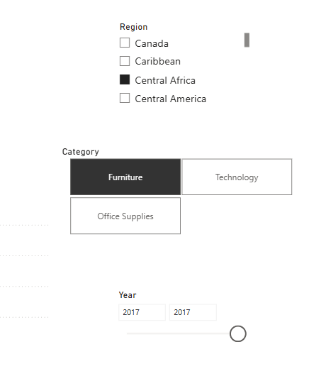
Fig 4.8: Multiple dimensional filters for OLAP Dicing

Step 12: Create Dicing visualizations.
Create visualizations showing:
• Sales by Region
• Total Sales by Segment
• Profit by Category
• Sales Trend by Year
The selected combination of Region, Category, and Year represents a smaller . . . multidimensional subset, demonstrating the Dicing operation.
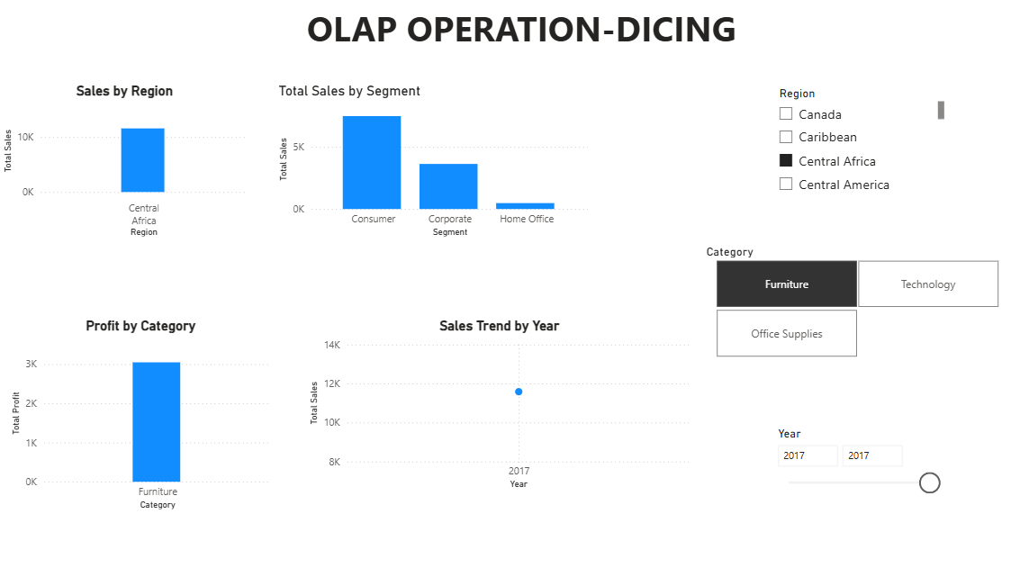
Fig 4.9: OLAP Operation – Dicing dashboard

Part E: Implement OLAP Drill Down
Step 13: Create the Drill Down worksheet.
Create a new Power BI report page and rename it:
OLAP Operation – Drill Down
Step 14: Create a geographical hierarchy.
Create a hierarchy containing geographical levels such as:
Region → Country → City → State
The hierarchy allows the user to move from summarized geographical information to . more detailed information.
Step 15: Enable Drill Down.
Add the geographical hierarchy to an appropriate visualization.
Enable the Drill Down functionality in the visual.
Move from:
Region → Country → City → State
to examine increasingly detailed geographical sales and profit information.
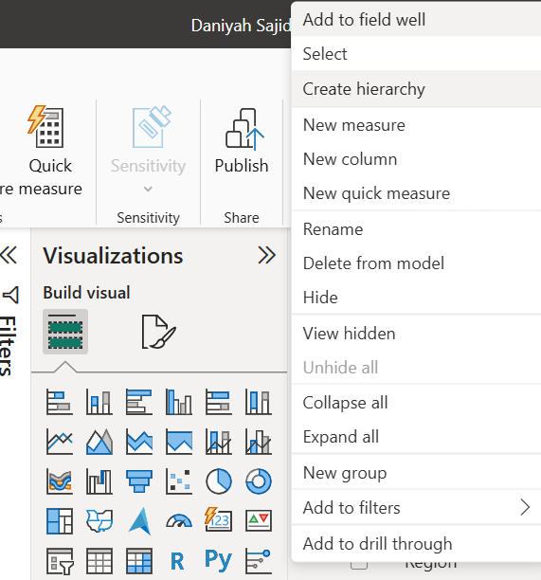 | 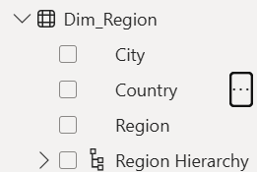 | 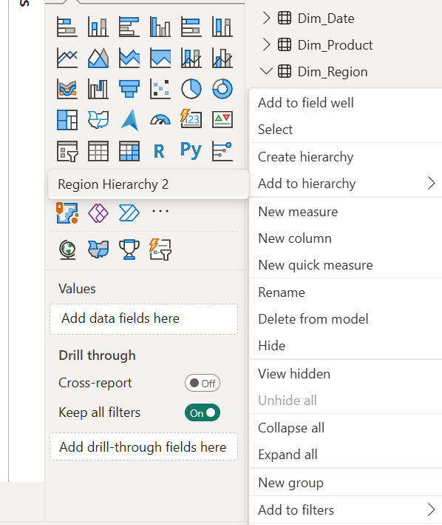 | 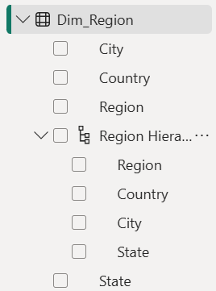
Step 1 | Step 2 | Step 3 | Step 4
Fig 4.10: Creation of geographical hierarchy for Drill Down

Step 16: Create Drill Down visualizations.
Create visualizations for:
• Sales by Geography
• Profit by Region
• Sales by Segment
Use the hierarchy to explore the data at different geographical levels.
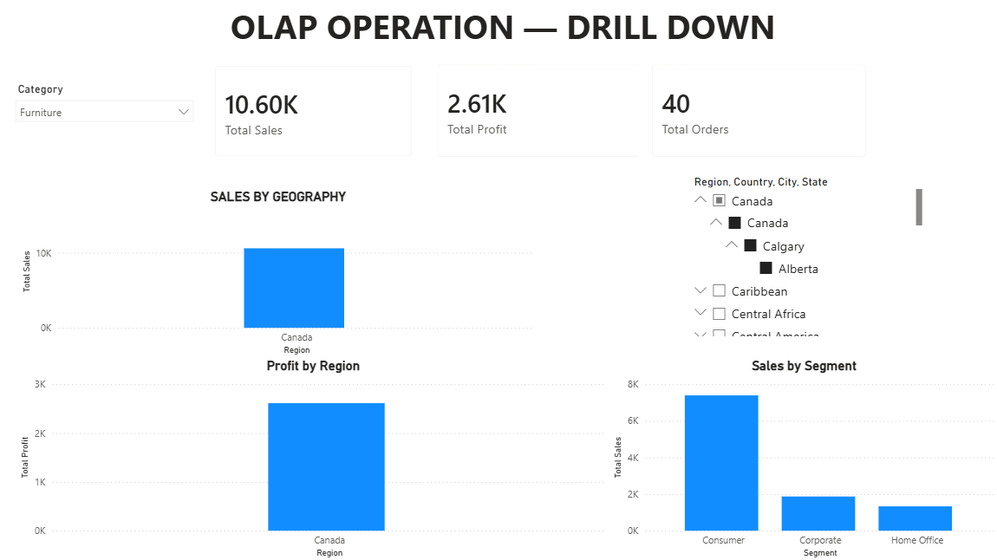
Fig 4.11: Enabling Drill Down in the geographical hierarchy

Part F: Implement OLAP Drill Up
Step 17: Create the Drill Up worksheet.
Create a new Power BI report page and rename it:
OLAP Operation – Drill Up
Step 18: Use the geographical hierarchy.
Use the same geographical hierarchy:
Region → Country → City → State
Start from a detailed level of geographical data.
Step 19: Perform Drill Up.
Use the Drill Up functionality to move from detailed information toward higher-level . summaries.
For example: State → City → Country → Region
This provides progressively summarized information for business analysis.
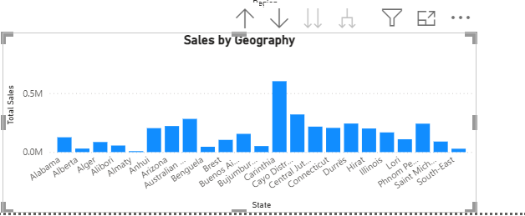 | 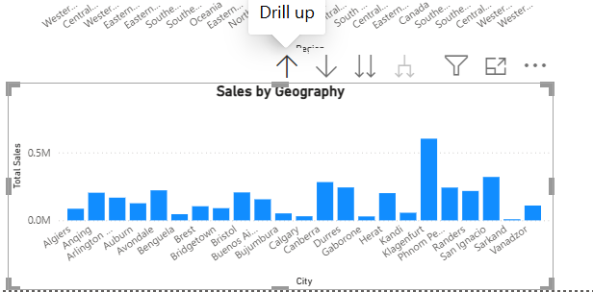 | 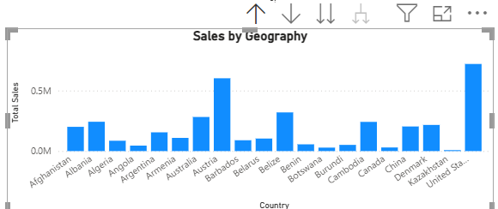
(a) | (b) | (c)
Fig 4.12: Enabling Drill Down in the geographical hierarchy

Step 20: Create Drill Up visualizations.
Create visualizations for:
• Profit by Region
• Sales by Geography
• Sales by Segment
• Total Sales
• Total Profit
• Total Orders
Use the category selection to analyse the summarized data for different product . . . categories.
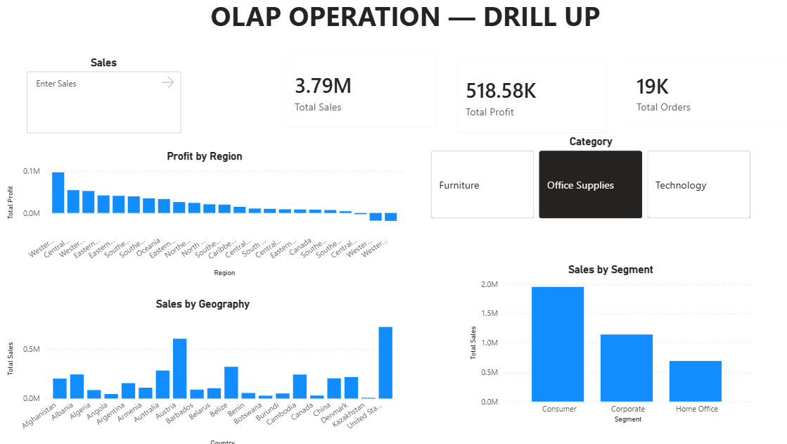
Fig 4.13: OLAP Operation – Drill Down dashboard

Part G: Validate OLAP Operations
Step 21: Validate Slicing.
Select different Regions from the Region slicer and verify that the corresponding Sales, . Profit, Orders, and charts change accordingly.
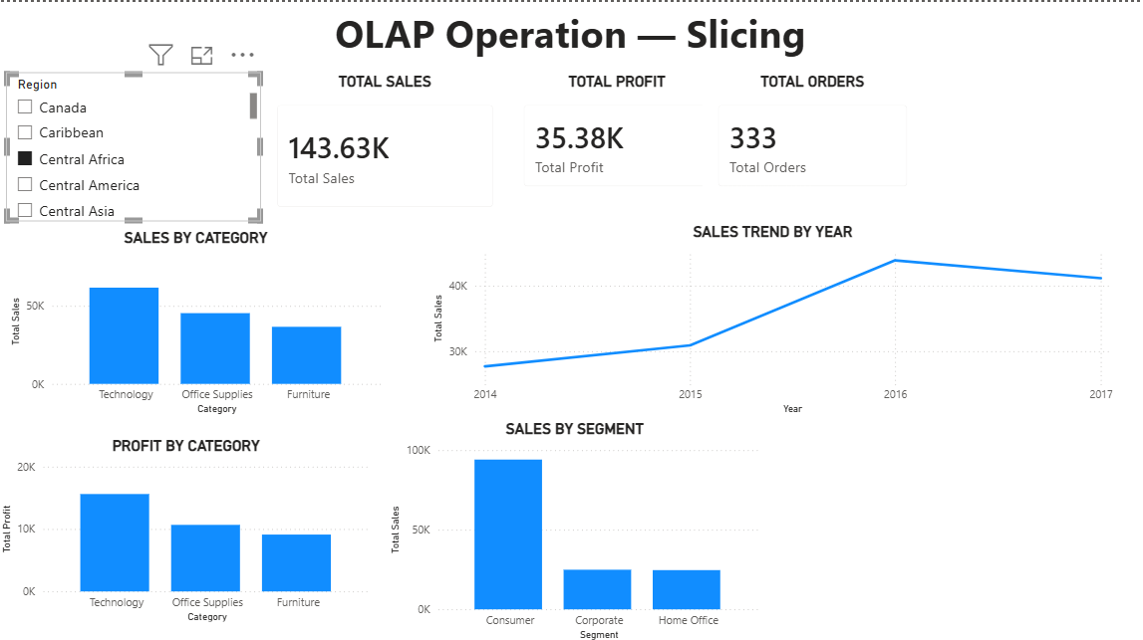 | 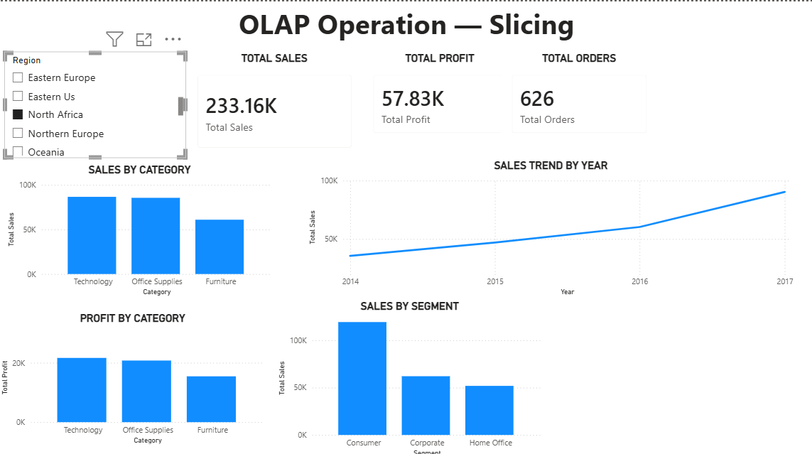
Fig 4.14: Validation of OLAP Slicing
Step 22: Validate Dicing.
Select different combinations of Region, Category, and Year and verify that the . . visualizations display only the selected subset of data.
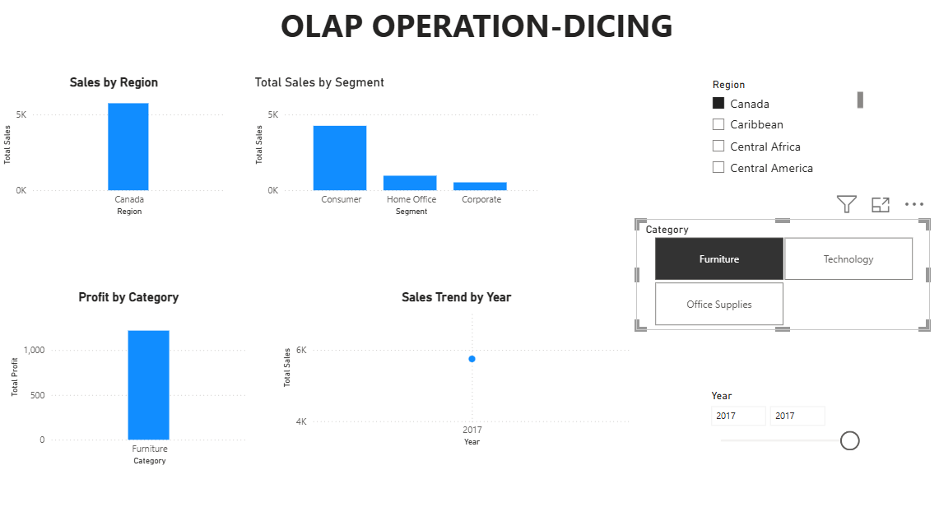 | 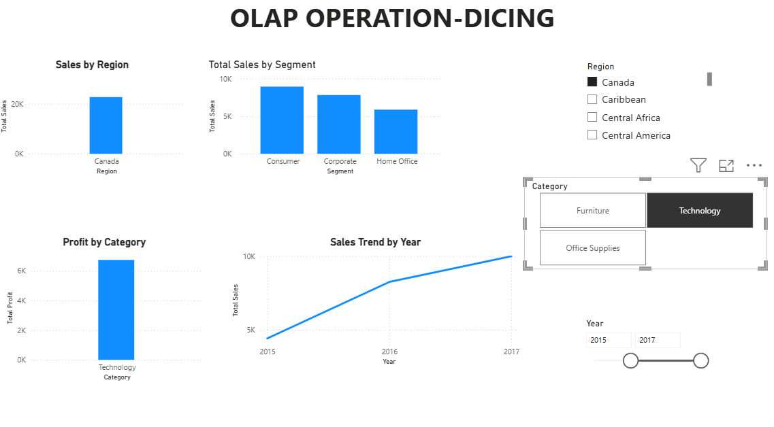
Fig 4.15: Validation of OLAP Dicing

Step 23: Validate Drill Down.
Move through the geographical hierarchy from higher-level information to lower-level . . details and verify that the visualizations display progressively detailed data.
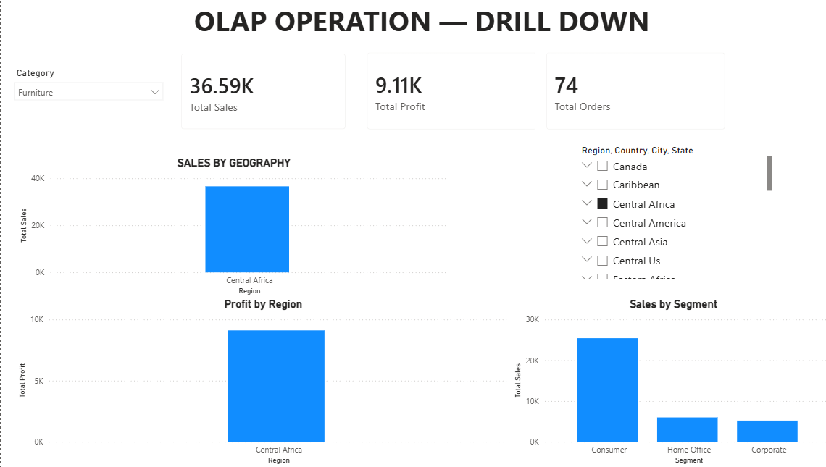 | 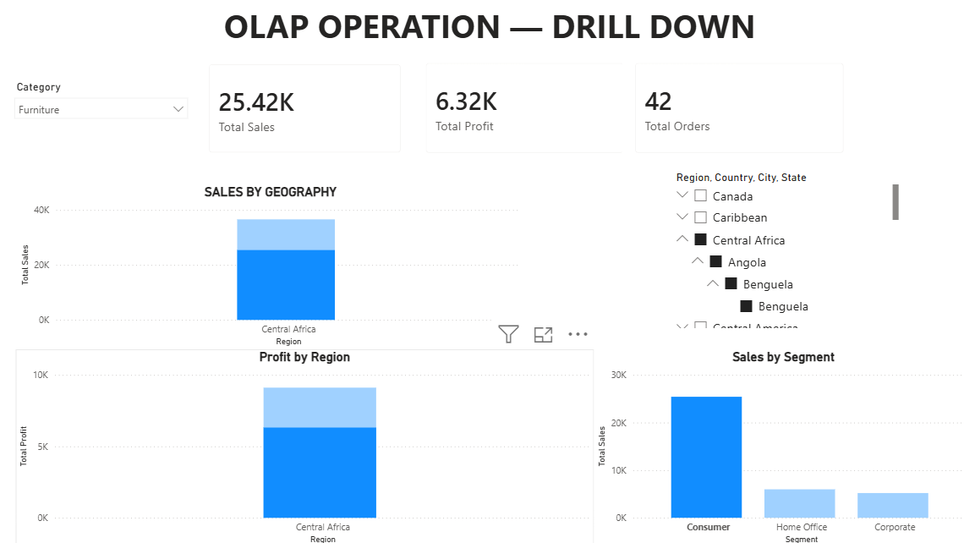
Fig 4.16: Validation of OLAP Drill Down

Step 24: Validate Drill Up.
Move from detailed geographical levels back toward higher-level summaries and verify . . that the data is aggregated correctly.
 | 
Fig 4.17: Validation of OLAP Drill Up

Step 25: Compare the OLAP operations.
Verify that each operation provides a different analytical perspective:
• Slicing → Analysis of a selected dimension/subset.
• Dicing → Analysis using multiple dimensional filters.
• Drill Down → Summary to detailed analysis.
• Drill Up → Detailed to summarized analysis.
- RESULT
The OLAP operations were successfully implemented using Microsoft Power BI on the Global Superstore dataset. Slicing and Dicing were used to analyse selected subsets of multidimensional data, while Drill Down and Drill Up were used to navigate between different levels of geographical detail. Interactive Power BI visualizations, slicers, filters, and hierarchies enabled effective analysis of Sales, Profit, Orders, Category, Segment, Region, and Year for business reporting and decision-making.
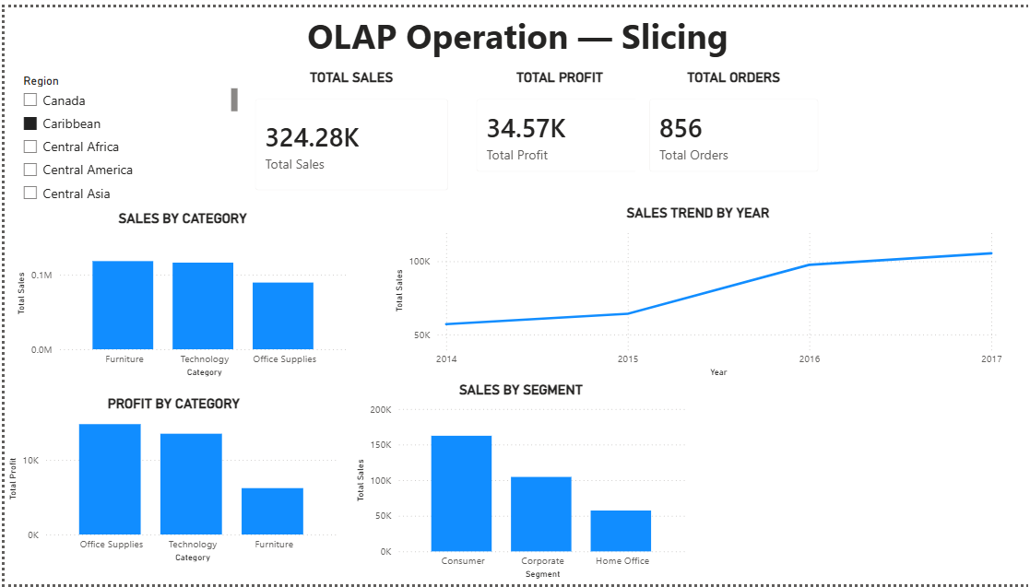
Fig 1.1: OLAP Operation – Slicing

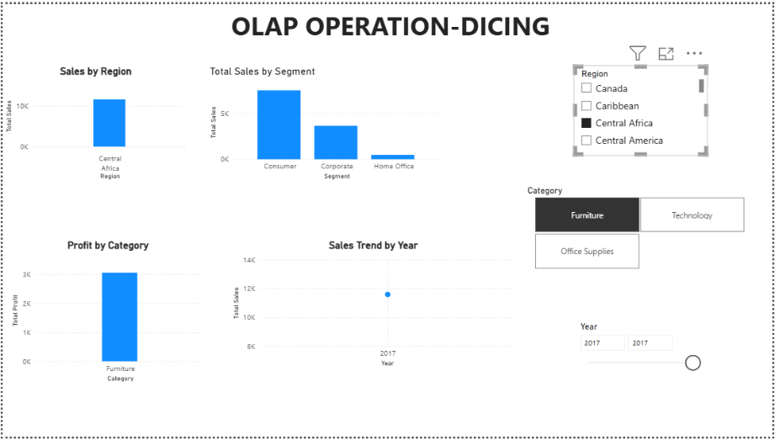
Fig 1.2: OLAP Operation – Dicing

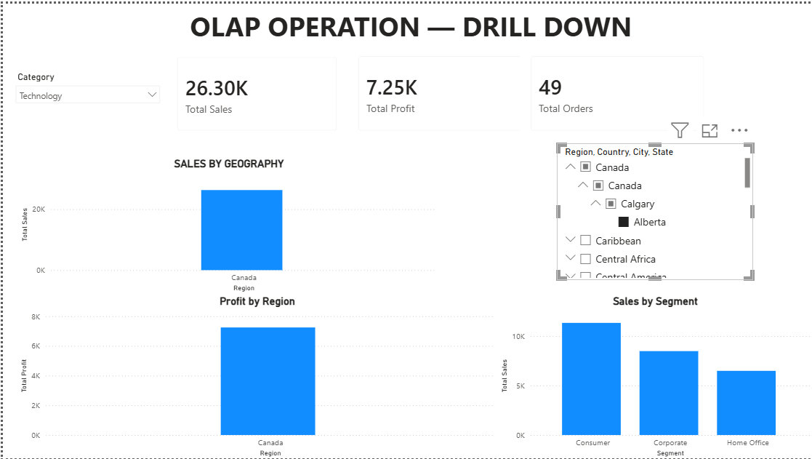
Fig 1.3: OLAP Operation – Drill Down

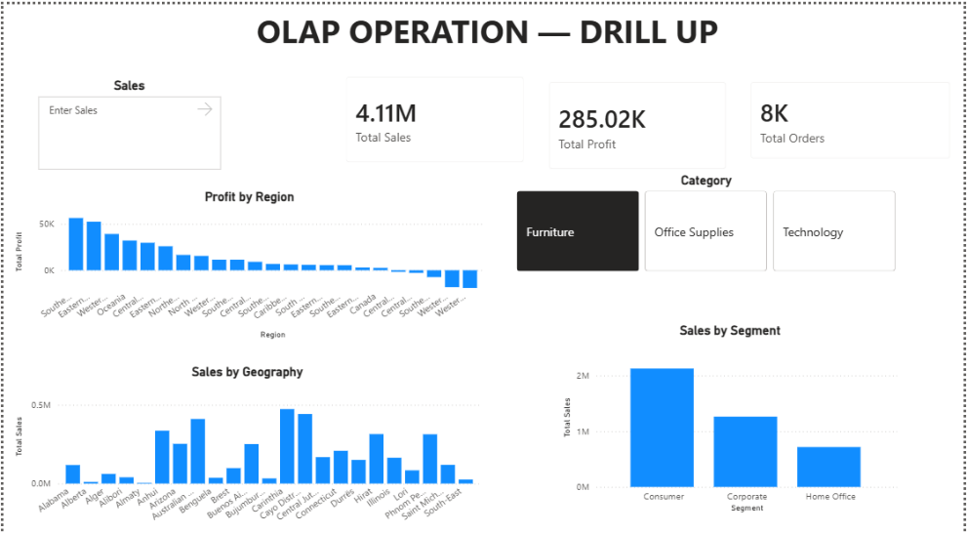
Fig 1.4: OLAP Operation – Drill Up

- LEARNING OUTCOMES
- Understood the concept of OLAP and its role in Business Intelligence.
- Learned how to perform multidimensional analysis using Power BI.
- Learned how to implement Slicing using slicers and filters.
- Learned how to implement Dicing using multiple dimensions.
- Learned how to create and use hierarchies for OLAP analysis.
- Learned how to perform Drill Down from summarized data to detailed data.
- Learned how to perform Drill Up from detailed data to summarized data.
- Gained practical experience in using interactive Power BI visualizations.
- Learned how to analyse Sales, Profit, Orders, Category, Segment, Region, and Year from different perspectives.
- Gained practical experience in applying OLAP operations for business analysis and decision-making.

